Database Archiving and Temporal

# Using In-Database Row Archiving

## Creating a Table and Enabling Row Archival

Connect to pdb1 as the HR user.

**. oraenv  
[Enter cdb1 at the prompt.]**

**sqlplus hr/hr@localhost:1521/pdb1**

Create a copy of the HR.employees table. Call the copy HR.emp_arch, and only copy over 4 rows.

**create table emp_arch  
as select employee_id, first_name from employees where rownum <= 4;**

Enable row archival on HR.emp_arch.

**alter table emp_arch row archival;**

There is a hidden column in row-archival-enabled tables called ora_archive_state which indicates whether a row is archived or not. The hidden column is only displayed if specified in a query. First, describe the table structure ofHR.emp_arch. Notice that the ora_archive_state column is **not listed**.

**desc emp_arch**

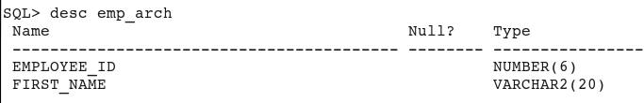

Now, query the HR.emp_arch table. Display the ora_archive_state column in the query result.

**select employee_id, first_name, ora_archive_state from emp_arch;**

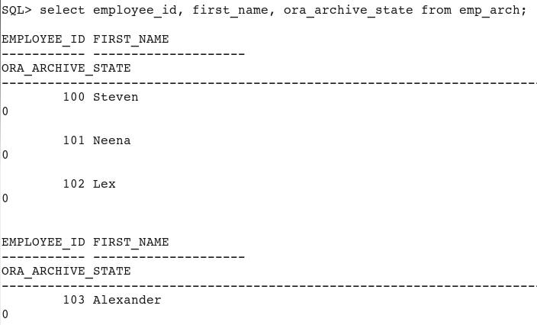

A value of 0 in the ora_archive_state column means the row is not archived; in other words, the row is active and visible via a standard query.

Confirm that all rows are active by issuing a standard query. You should see all 4 rows.

**select * from emp_arch;**

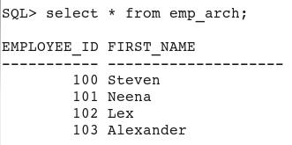

## Setting the Archive State of Some Rows

Use the dbms_ilm.archivestatename procedure to update the ora_archive_state value for employee_id 102 and 103.

**update emp_arch  
set ora_archive_state=dbms_ilm.archivestatename(1)  
where employee_id in (102, 103);**

**commit;**

Confirm that now only 2 rows are visible via a standard query. Include the ora_archive_state column in the query. The ora_archive_state value for the 2 rows should be 0.

**select employee_id, first_name, ora_archive_state from emp_arch;**

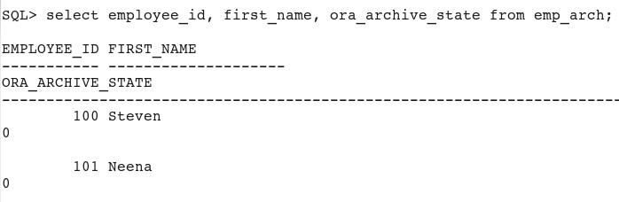

## Enabling a Session to View Archived Rows

Set the archival visibility to ALL for the session. This will allow this session to view all rows, archived or not.

**alter session set row archival visibility = all;**

Issue the same query as before, but now you should see all 4 rows.

**select employee_id, first_name, ora_archive_state from emp_arch;**

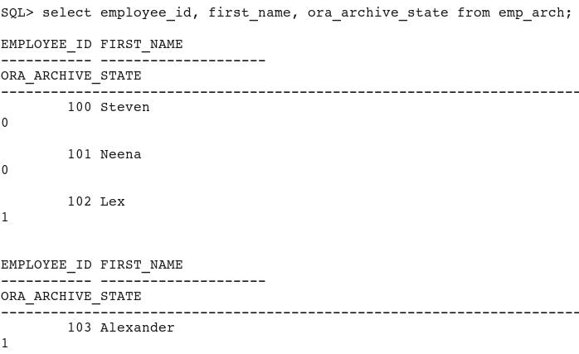

Set the archival visibility to ACTIVE for the session. This will allow this session to view only active (unarchived) rows.

**alter session set row archival visibility = active;**

Issue the same query as before, but now you should see only the 2 active rows.

**select employee_id, first_name, ora_archive_state from emp_arch;**

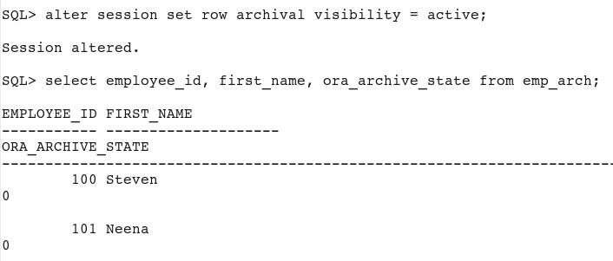

## Verifying that Copying a Row-Archival Table Will Not Propagate the Source Table's Archival State to the Target Table

Use CTAS to make a copy of the HR.emp_arch table.

**create table emp_arch_copy as select employee_id, first_name from emp_arch;**

Verify that HR.emp_arch_copy does not have row archival enabled, and therefore does not contain the ora_archive_state hidden column. You should see an "invalid identifier" error for this query.

**select employee_id, first_name, ora_archive_state from emp_arch_copy;**

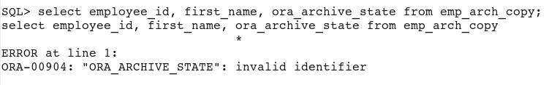

Query the table again, but this time omit the hidden column. Notice that all 4 rows are copied even though you set the row archival visibility for this session to active rows only.

**select employee_id, first_name from emp_arch_copy;**

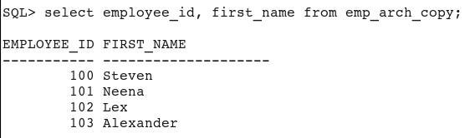

Set the archival visibility to ALL for the session. From this point forward, this session should now see all rows, whether archived or not.

**alter session set row archival visibility = all;**

Enable row archival for HR.emp_arch_copy.

**alter table emp_arch_copy row archival;**

Verify that HR.emp_arch_copy now has row archival enabled, and therefore contains the ora_archive_state hidden column.

**select employee_id, first_name, ora_archive_state from emp_arch_copy;**

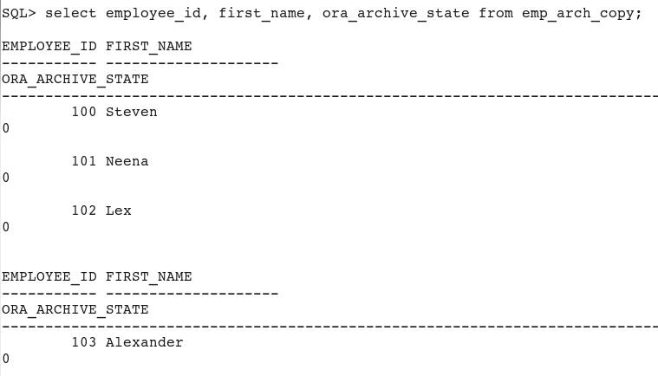

Use the dbms_ilm.archivestatename procedure to update the ora_archive_state value for employee_id 102 and 103.

**update emp_arch_copy  
set ora_archive_state=dbms_ilm.archivestatename(1)  
where employee_id in (102, 103);**

**commit;**

Confirm that now 2 rows are active, and 2 rows are inactive, via a standard query. Include the ora_archive_state column in the query. The ora_archive_state value for the 2 active rows should be 0, and the 2 inactive rows should be 1.

**select employee_id, first_name, ora_archive_state from emp_arch_copy;**

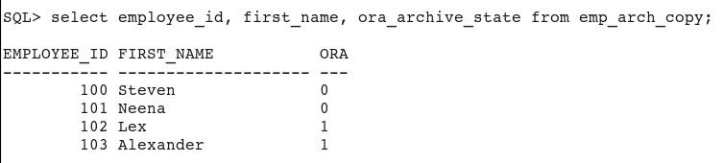

Recall that the HR.emp_arch table you created earlier contains 2 active and 2 inactive rows. Confirm this via a standard query. Include the ora_archive_state column in the query. The ora_archive_state value for the 2 active rows should be 0, and the 2 inactive rows should be 1.

**select employee_id, first_name, ora_archive_state from emp_arch;**

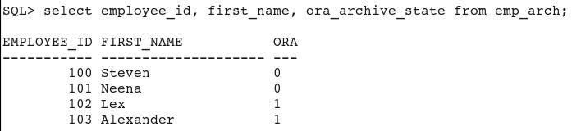

Copy all rows from HR.emp_arch to HR.emp_arch_copy. To distinguish between rows that were previously copied to HR.emp_arch_copy via CTAS, and the rows being copied again now, append '_New' to the values in thefirst_name column values.

**insert into emp_arch_copy select employee_id, first_name || '_New' from emp_arch;**

**commit;**

What row archival state do you think the newly inserted rows have? Remember that the archival state is not copied along with the rows.

Query HR.emp_arch_copy to determine the ora_archive_state value for each row.

**select employee_id, first_name, ora_archive_state from emp_arch_copy;**

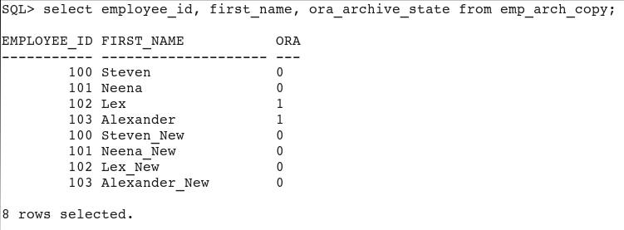

You should see that the ora_archive_state values from HR.emp_arch are not propagated to HR.emp_arch_copy. All of the _New rows in HR.emp_arch_copy have ora_archive_state set to the default value of 0 (active). The 2 inactive rows resulted from the update you performed in the HR.emp_arch_copy table in step 7.

## Resetting Your Environment

Perform the following steps to reset your environment prior to repeating the activities covered in this OBE or starting another OBE.

Drop the tables created in this tutorial.

**drop table emp_arch;**

**drop table emp_arch_copy;**

# Implementing Temporal  Validity

****Only support to non-cdb

## Creating a Table with a Valid-Time Dimension

Using SQL*Plus, connect to noncdb database as sys.

**sqlplus system/oracle@localhost:1521/noncdb**

Create a copy of the HR.employees table. Call the new table HR.emp_temp.

**create table hr.emp_temp as   
select employee_id, first_name, salary   
from hr.employees  
where rownum <=10;**

Add a valid-time dimension to the HR.emp_temp table.

**alter table hr.emp_temp add period for valid_time;**

View the HR.emp_temp table structure.

**desc hr.emp_temp**

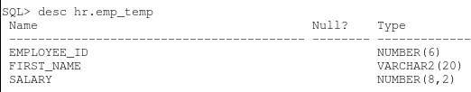

Notice that the valid-time columns are not displayed because they are hidden columns and must be explicitly included in a query.

Display all records in HR.emp_temp, including the valid-time columns.

**select first_name,  
to_char(valid_time_start,'dd-mon-yyyy') "Start",  
to_char(valid_time_end,'dd-mon-yyyy') "End"  
from hr.emp_temp;**

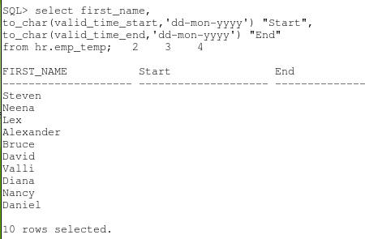

Update the records and populate the valid-time columns.

**update hr.emp_temp  
set valid_time_start = to_date('01-JUN-1995','dd-MON-yyyy'), valid_time_end = to_date('15-SEP-2010','dd-MON-yyyy')  
where first_name in ('Lex','Alexander','Bruce','David','Daniel');**

**update hr.emp_temp  
set valid_time_start = to_date('01-AUG-1999','dd-MON-yyyy'), valid_time_end = to_date('01-MAR-2012','dd-MON-yyyy')  
where first_name in ('Steven','Diana');**

**update hr.emp_temp  
set valid_time_start = to_date('20-MAY-1998','dd-MON-yyyy')  
where first_name in ('Neena','Nancy','Valli');**

**commit;**

Display all records in HR.emp_temp, including the valid-time columns.

**select first_name,  
to_char(valid_time_start,'dd-mon-yyyy') "Start",  
to_char(valid_time_end,'dd-mon-yyyy') "End"  
from hr.emp_temp  
order by 2;**

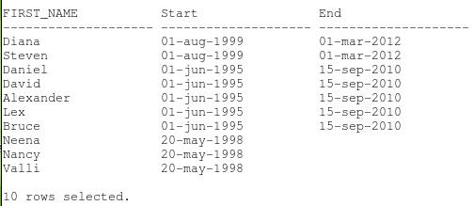

## Querying a Table with Valid Time Support

Here are some examples of queries on tables with valid time support.

Find all employee records which are still valid as of 01-JUN-2011.

**select first_name,  
to_char(valid_time_start,'dd-mon-yyyy') "Start",  
to_char(valid_time_end,'dd-mon-yyyy') "End"  
from hr.emp_temp  
as of period for valid_time to_date('01-JUN-2011')  
order by 2;**

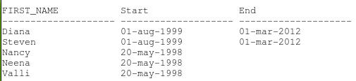

Find all employee records which are valid between 01-SEP-1995 and 01-SEP-1996. This query should return all records where valid_time_start >= 01-SEP-1995 and valid_time_end <= 01-SEP-1996.

**select first_name,  
to_char(valid_time_start,'dd-mon-yyyy') "Start",  
to_char(valid_time_end,'dd-mon-yyyy') "End"   
from hr.emp_temp   
versions period for valid_time   
between to_date('01-SEP-1995') and to_date('01-SEP-1996')   
order by 2;**

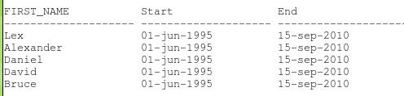

## Setting Visibility of Temporal Data with DBMS_FLASHBACK_ARCHIVE.ENABLE_AT_VALID_TIME

To set the visibility of data in tables with temporal support, you use the DBMS_FLASHBACK_ARCHIVE.enable_at_valid_time procedure.

Only make visible the currently valid records in HR.emp_temp.

**exec dbms_flashback_archive.enable_at_valid_time('CURRENT');**

Query HR.emp_temp. Which records are currently valid and will be displayed?

**select first_name,  
to_char(valid_time_start,'dd-mon-yyyy') "Start",  
to_char(valid_time_end,'dd-mon-yyyy') "End"  
from hr.emp_temp  
order by 2;**

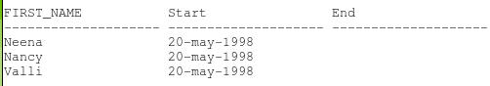

Make all records in HR.emp_temp visible, regardless of their temporal validity status.

**exec dbms_flashback_archive.enable_at_valid_time('ALL');**

Query HR.emp_temp. All records should be displayed.

**select first_name,  
to_char(valid_time_start,'dd-mon-yyyy') "Start",  
to_char(valid_time_end,'dd-mon-yyyy') "End"  
from hr.emp_temp  
order by 2;**

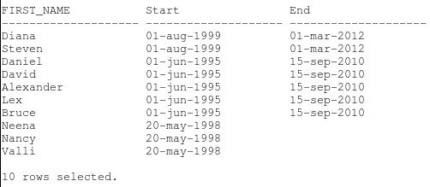

## Resetting Your Environment

Perform the following steps to reset your environment prior to repeating the activities covered in this OBE or starting another OBE.

Drop the HR.emp_temp table.

**drop table hr.emp_temp purge;**